ER Diagram
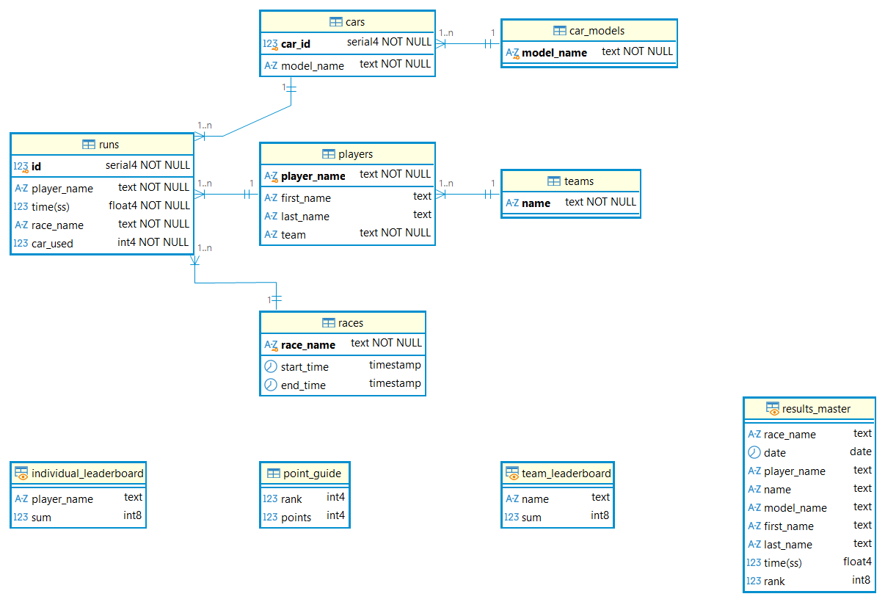
While conceptually the cars – models, runs-players, runs-cars relationships would be [0:n]-[1:1], DBeaver displays them as [1:n]-[1:1]. Runs-races have [2:n]-[1:1] cardinality – this rule I could not enforce into the modelling part, however it is utilized when team results are filtered in the team_leaderboard.

team_leaderboard
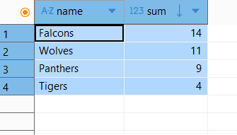
CREATE VIEW team_leaderboard AS
SELECT teams.name, SUM(points)
FROM teams
LEFT JOIN results_master USING (name)
LEFT JOIN point_guide USING (rank)
GROUP BY teams.name
HAVING teams.name IN(
SELECT team
FROM players
);

individual_leaderboard
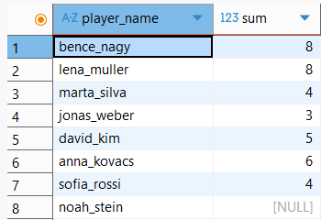
CREATE VIEW individual_leaderboard AS
SELECT players.player_name, sum(points)
FROM players
LEFT JOIN results_master USING (player_name)
LEFT JOIN point_guide USING (rank)
GROUP BY players.player_name;

results_master view
CREATE VIEW results_master AS
SELECT
race_name,
DATE(races.start_time),
runs.player_name,
name,
model_name,
first_name,
last_name,
runs."time(ss)",
RANK() OVER (
PARTITION BY race_name
ORDER BY runs."time(ss)" ASC
) AS rank
FROM races
INNER JOIN runs USING (race_name)
LEFT JOIN cars ON runs.car_used = cars.car_id
LEFT JOIN car_models USING (model_name)
LEFT JOIN players USING (player_name)
LEFT JOIN teams ON teams.name = players.team
WHERE race_name IN (
SELECT race_name
FROM runs
GROUP BY race_name
HAVING COUNT(DISTINCT player_name) >= 2
);
-- a race is displayed only if there are at least two players;

